Question 1: Name of employee work in deptno with the job_Id” use last_name coloum

Ans:

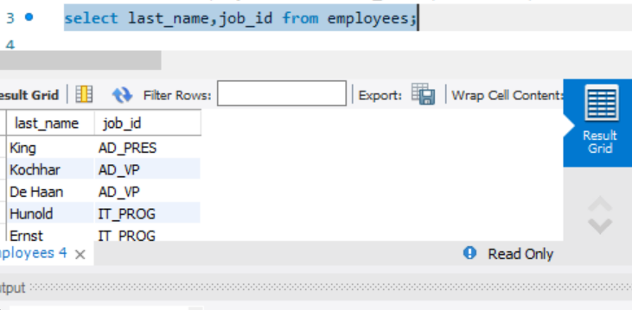

Question 2: Employees who joined in the year 2000

Ans:

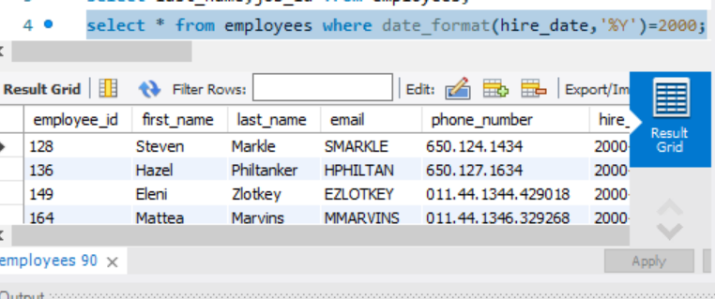

Question 3: Emploees who joined in after jan_1996

Ans:

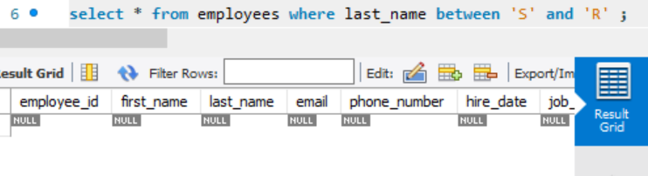

Question 4: Employess whose name starts between ‘S’ to ‘R’

Ans:

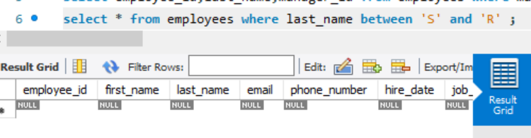

Question 5: Employees who works under manger_id (200,201)

Ans:

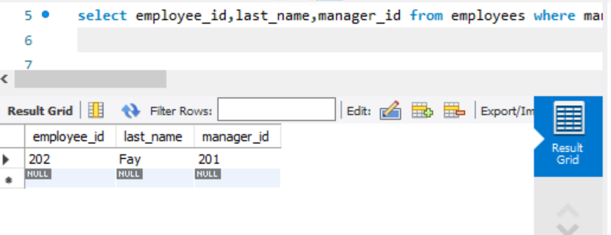

Question 6: Employees who are “REP”(representatives) or “MAN”(salesmans) and who are paid more than 6000

Ans:

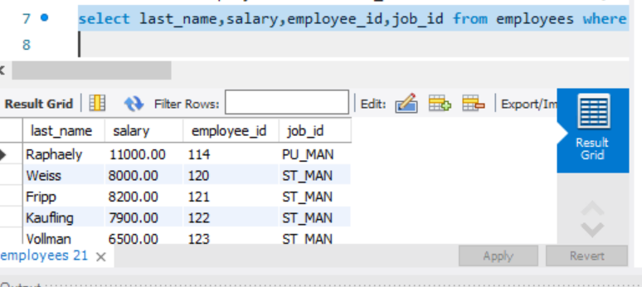

Question 7: Calculate annual salary of each employee and print them in descending order

Ans:

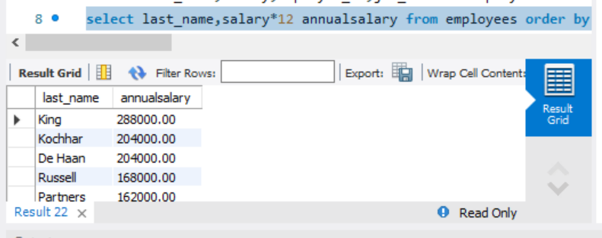

Question 8: Replace the last_name of “Landry” to “JOE” in the employee table

Ans:

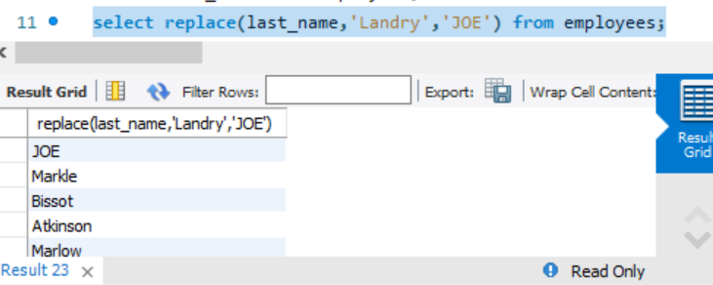

Question 9: Find the position of first occurance of the character ‘o’ in the last_name of all employees who have ‘o’ in their last_name.

Ans:

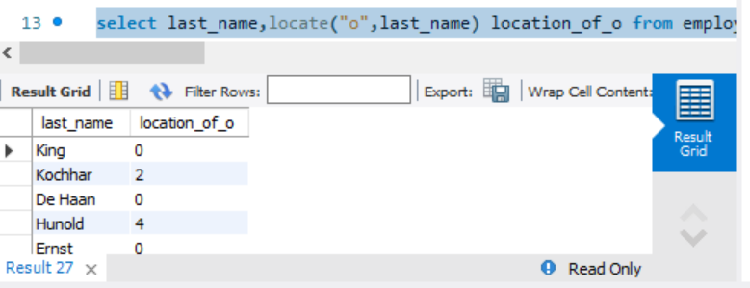

Question 10: Prefix “2020_B84” for employee last_names who works in department 90

Ans:

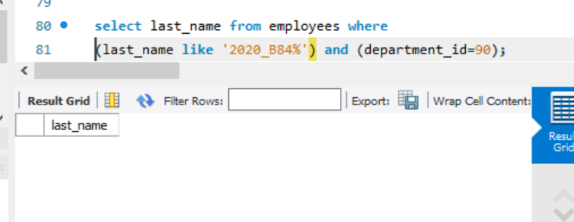

Question 11: Find the current date with local date and time

Ans:

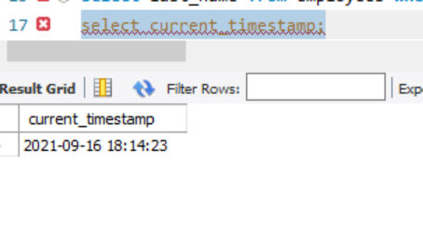

Question 12: Find the average commission paid for all the employees (ignoring the null entries)

Ans:

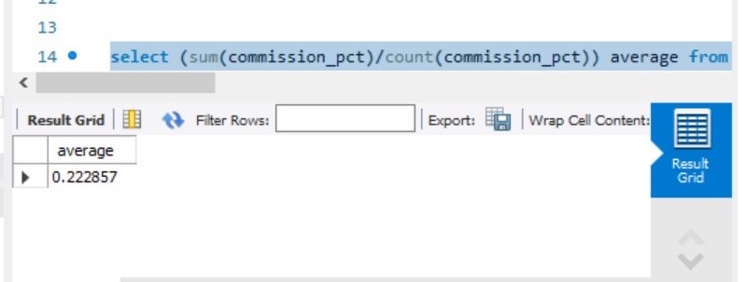

Question 13: Find the average and highest salary paid for department 80,90,100

Ans:

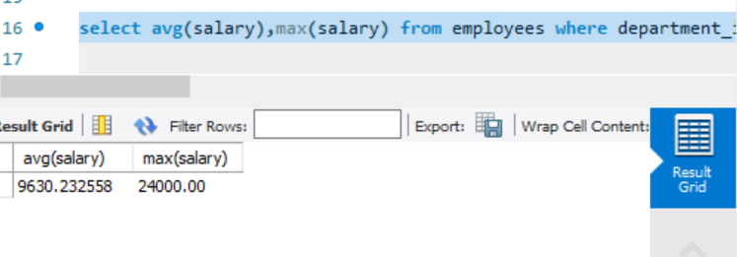

Question 14: Find the department id where the highest paid employee salary is more than 1000.

Ans:

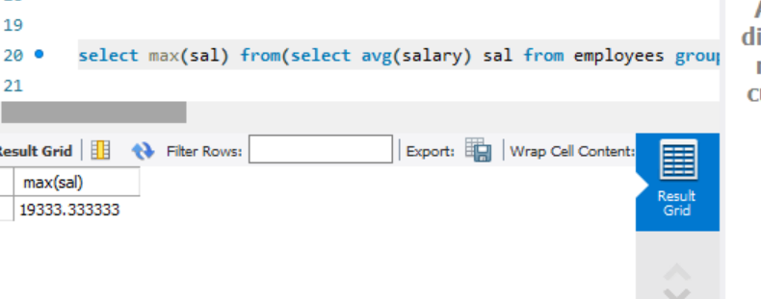

Question 15: Find the department id who is paid the maximum average salary in the organization: use subqueries

Ans:



* Question 16: Find the departmentname and loacation_id in which ‘Ernst’ work.

Ans:

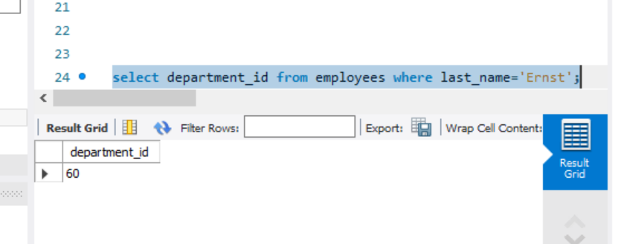

Question 17: Find all the employee names who work in “Tokyo” city ( use subqueries , table used : employees, departments, locations )

Ans:

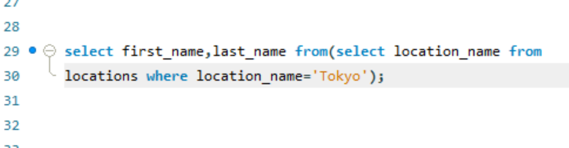

Question 18: Find the employee names who are the maximum paid salary in the organization

Ans:

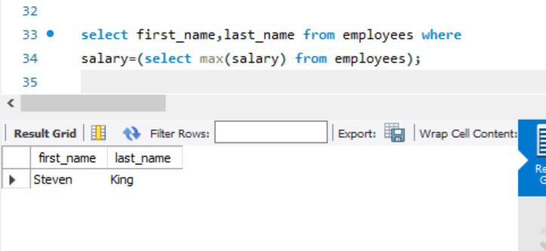

Question 19: Find the employees who are drawing minimum salary in their respective departments

(Use the jobs table for getting the min salary and use subquries )

Ans:

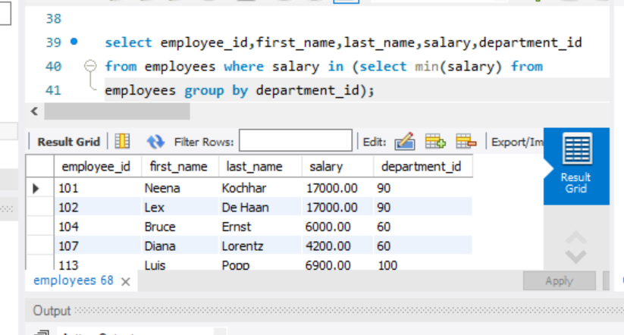

Question 20: Find the employee names and their job_id and job_titles by joining employee and jobs table

Ans:

